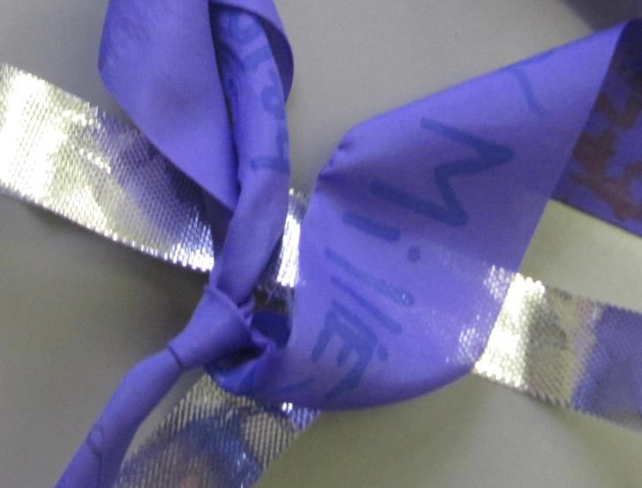

**Thankful Ribbons**

Instructions:

Equipment needed:

This activity encourages

pupils

to think about

someone or

something

that they are thankful

for

and to express their gratitude and ‘thank

you pra

yers’ with movement

.

Option 1: prepare lots of individual pieces of

ribbons and sticks for each student.

Option 2: prepare

one

(

or a few)

long piece

s

of

ribbon

,

which is attached to a large

pole. In

both cases ensure that pens are easily

available.

E

ncourage

each

pupil

to think about

one thing

they are thankful

for

and to

then write it down

on the ribbon. If they want to, they can say a

silent prayer as they do this.

If you have enough s

pace,

younger

pupils

might enjoy

swirl

ing

the ribbon

s

around and

even dancing to some

music.

A prayer activity inspired by rhythm

ic

gymnastics

that

encourage thankfulness.

F

ind more like this at

prayerspacesinschools.com

This resource is licensed under a Creative Commons Attribution

-

NonCommercial

-

ShareAlike

4.0

International licence. See the copyright policy on the Prayer Spaces in Schools website for more details.

Lengths of ribbon and sticks (with non

-

sharp

ends) or pre

-

made streamers

Pens (ideally fabric pens)

Optional:

CD player

Music

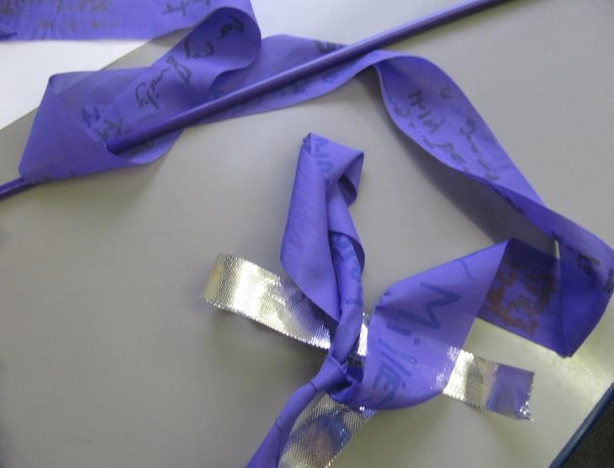

*Below is an example of the instructions you could*

*use for this activity. Please feel free to copy these*

*and adapt as you wish. If your prayer space has a name you might wish to add your own logo.*

**Thankful Ribbons**

Think of

someone or

something that you are really

thankful for.

If you want to, you can w

rite

or draw a

thought or

prayer about it onto the

ribbon.